1. Run a regression of revenues on advertising. Is advertising having a significant impact on revenues? Interpret the intercept and slope.



The B coefficient =154.39

Standard error = 6.83

T test value =22.60

P-value =1.02E-16

The value of r square is 0.9587. It shows that 95.87 % variability in revenue is explained by advertisement. The analysis of variance (ANOVA) also indicates the regression effect is significant (p value =1.02016E-16).

Intercept =-24793.51 , slope =154.39

If there is no advertising (advertising expense = 0) then the value revenue will be negative ( -24793.51).

The impact of advertising on revenue is 154.39 and the chances of advertising having no impact on revenue is close to 0(1.02E-16),

1. Construct a residual plot. Do the residuals appear random? Do they satisfy the first three assumptions?

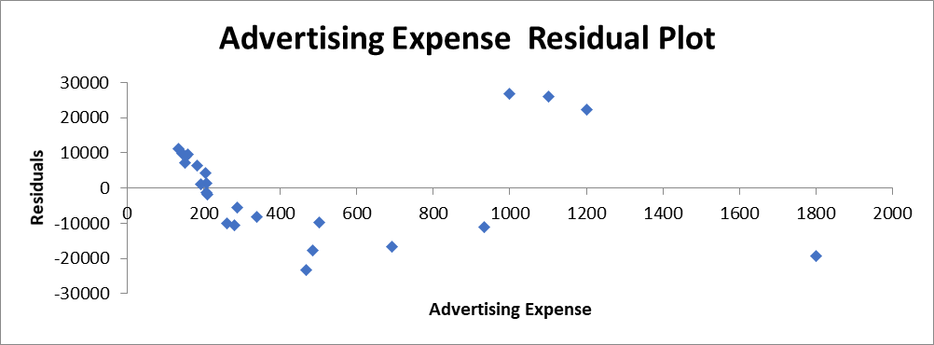

The residual plot appears to be random.

The first 3 three assumptions are:

1. The error term ε is a random variable with an expected value of 0 with an expected value of X.-The value of sum difference between the given revenue and the predicted revenue is close to 0 (2.18278E-10).
2. The variance of ε is a constant for all values of X-the variance of ε is
3. The value of εi  are independent
4. Construct a Q-Q plot. Do the residuals appear to be normally distributed? (2 points)

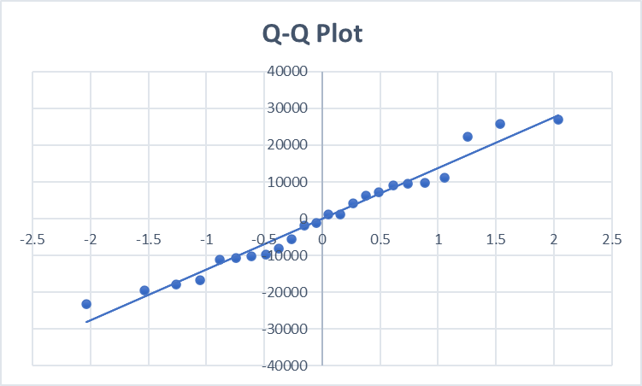

The residual seems to be normally disturbed thru the Q-Q plot chart.

1. If advertising expenses were to be 1500 in 2016, what would your prediction interval for revenues? (2 points)